
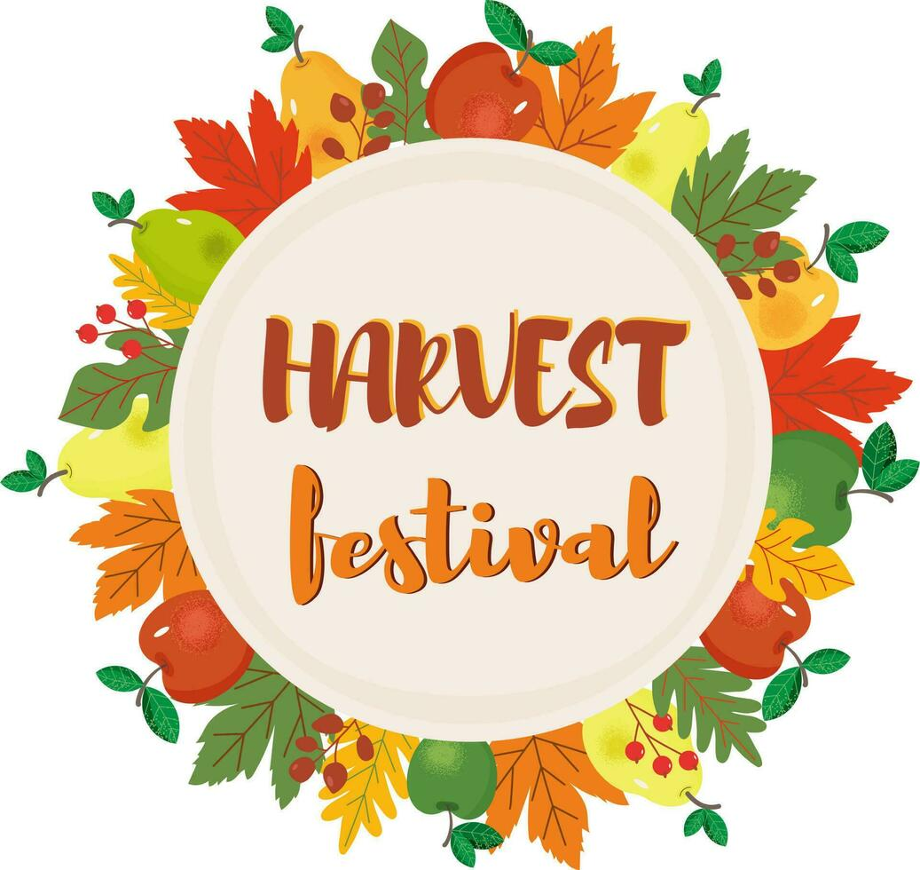
Tuesday 21st October 2025
9:30am
Pendock Cross Church

Order of Service

Welcome – Ms. Moon

Whole School & congregation– Cauliflowers Fluffy
(please join in!)

Class 1 – Harvest pictures

Class 2 and Pendock Choir – Harvest Samba

Class 3 – Harvest Around the World

Class 4 – Harvest Moon poems

Whole School – Big Red Combine Harvester

Closing remarks – Rev. Anthea

Thank you – Ms. Moon


