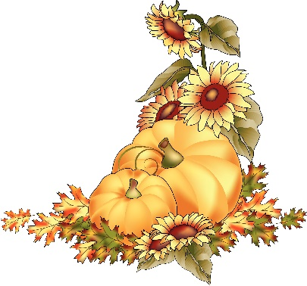
Class 3 Autumn 2 Curriculum Newsletter.

Welcome back! We hope that you have had an enjoyable half term break. We are glad to welcome the children back to school and are thoroughly looking forward to the term ahead.

Key Information:

Forest School will be every other Wednesday they can come to school in their own clothes and bring waterproofs as they are likely to get muddy.


Help from Home:

We recognise the invaluable role which parents and carers play in their child’s education. To support your child, we ask:

- Drop children at school in plenty of time.

- Read daily with your child; even just 5 minutes can make such a huge difference!

- Please label everything.


Learning.

English.
We continue to support children to develop their sentence writing, using capital letters, finger spaces and full stops consistently and independently.

We will have a big focus on handwriting throughout the Autumn term and will support children in applying this consistently and independently in their writing.

Children have been introduced to the different word classifications, such as nouns, adjectives and verbs and supported to appropriately use these in their writing. Moving forward, children will write increasingly independently for a specific purpose and extend their writing to include more complex and compound sentences.

In Class 3 we will explore Greek myths and legends, writing narratives whilst exploring different myths throughout our curriculum.


Maths.

Learning in Maths will focus on Multiplication and Division, Position and direction.

Children will also receive weekly Maths Fluency sessions where we will focus on timetables to help build their confidence and fluency.


Science.
Children will be encouraged to work scientifically by performing simple tests, observing closely and recording data to help answer questions they have devised.

In the Autumn term, children will learn about Rocks and looking at the different types of rocks and how they are formed.

Foundation Subjects.

History | Ancient Greeks
Religious Education (RE) | What is it like for someone to follow God?
Personal, Social and Health Education (PSHE) | Rights and Responsibilities
Design and Technology (D.T) | Fabric Drawstring bag
Physical Education (PE) | Swimming
Please do not hesitate to get in touch should you have any queries.
We are really looking forward to an exciting Autumn 2!
Thank you for your continued support,
Class 3 Team

