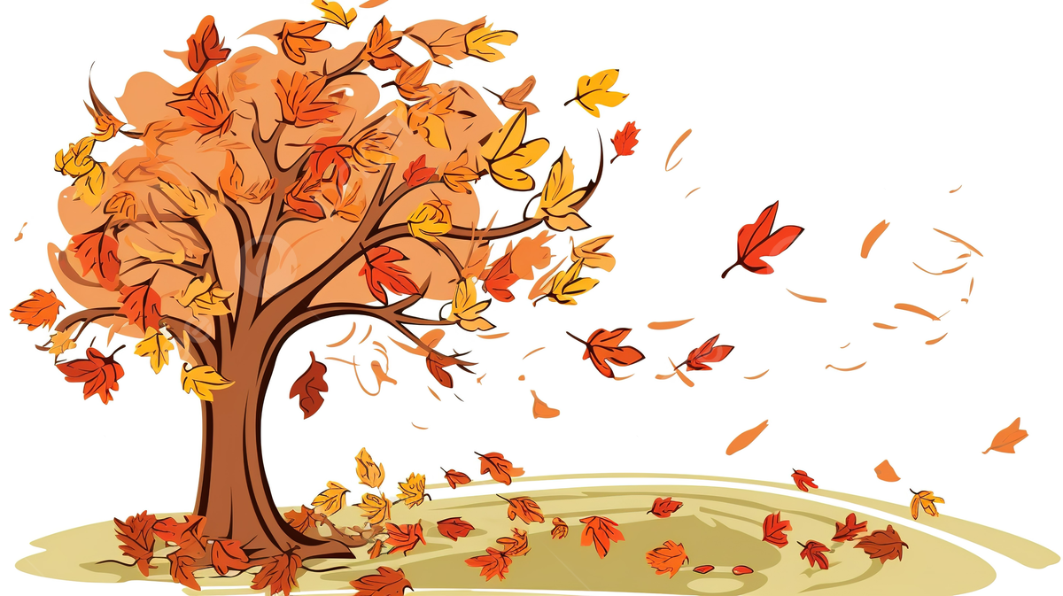
KS1
Autumn 2 Curriculum Newsletter

Key Information:

P.E will be every Tuesday throughout the year.

Forest School – every other Wednesday. Please send children in appropriate clothing. Wellies and waterproofs can be left in school.


Help from Home:

Whilst we will, of course, support all children as necessary in school, we really appreciate your support from home with reading and Numbots.

Learning.

Phonics
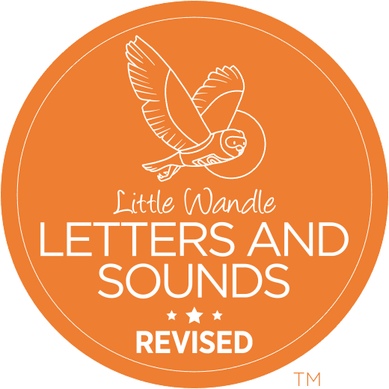
At Pendock, we follow a Phonics scheme called ‘Little Wandle’. Children in Year 1 are taught phonics throughout the year. Children in Year 2 are following ’Little Wandle Spelling’, this will also run throughout the year.

During Autumn 2, the Year 1 children will be focusing on learning their phase 5 sounds. Before half term, the Year 2 children have begun the ‘Bridge to Spelling’ unit which teaches the foundational skills for spelling.

Children will continue to receive reading books from school to be read at home. Books will be changed every Friday.

Books coming home:

Year 1

1 x Phase Book – children have read this book in school during the week. Encourage them to read this book independently at home.
Year 2
1x Fluency Chapter Book – children will be reading these books in school. Encourage them to read this book independently at home.

Year 1 and 2
1 x Band Book – this book is closely matched to your child’s phonics learning, providing some level of stretch and challenge. Encourage them to read this book as independently as possible at home but they may require some support.

1 X Sharing Book – this is a free choice book that your child has chosen from the School Library to share with you at home. Look and talk about the pictures in the book together, encourage your child to read but, most importantly, enjoy sharing this book with your child!

English.

Year 1 and 2 children have English lessons daily.


In English, the children will continue to develop their letter formation and handwriting. In KS1 we use handwriting lines to support this, the Year 1 children have been developing their confidence with these. Year 2 children have been enjoying learning to use pre-cursive writing.

We will support the children to develop their sentence writing, using capital letters, finger spaces and full stops.

Throughout the Autumn term, the children will be introduced to a range of writing genres. This half term we will be focusing on setting descriptions, instructions and a newspaper article.

Maths

Year 1 and 2 also have daily Maths sessions.

During the Autumn term, the children will cover the following:
- Shape
- Place Value (within 100)
- Statistics
Science

Year 1 and 2 children have science lessons weekly.

This half term they will be learning about everyday materials. The children will learn to separate the object from the material is made from. They will also learn about the properties of materials such as wood, glass and metal.

Foundation Subjects.

History | Are toys better now than they used to be?
Religious Education (RE) | What do Christians believe God is like?
Personal, Social and Health Education (PSHE) | Rights and responsibilities
Computing | Creating media – digital painting
Music | Tempo – snail and mouse
Design and technology | Puppet Pal
Physical Education (PE) | Swimming

===============================================
Thank you for your continued support,
Miss Chambers

